Hello,

I have installed ShP HD and localized it in Czech language. It looks good but titles of ticket (Views) are not translated. It is big issue, because it is well showed. I am sending a picture of it below, buttons are translated but titles are not:
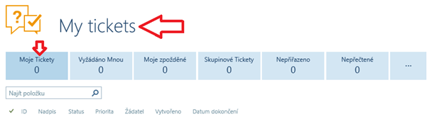
The issue is included in all the Views and also under three dots -> All tickets (also not translated):
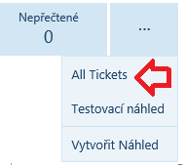
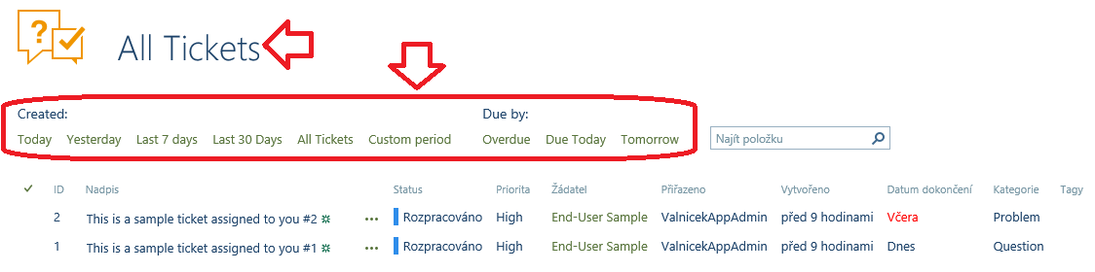
I tried to find it in site/HD -> localization -> cs-CZ.js but I found all the item translated there.
Can you help me how to solve the issue please? Thank you.

