Issue 1: Printing to PDF is inconsistent. Web part displays page with all employee images, but randomly omits images from PDF creation.
Issue 1 Example (there are others I can send if need be):
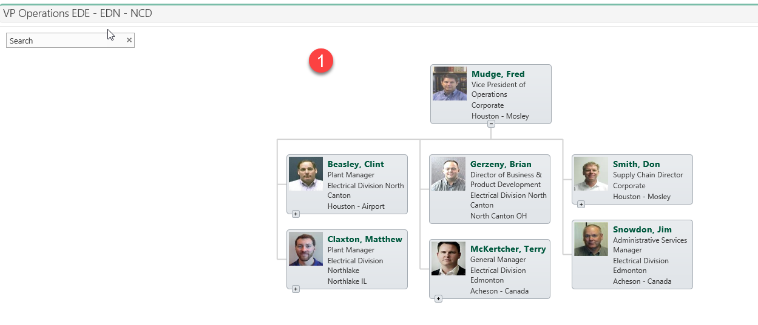
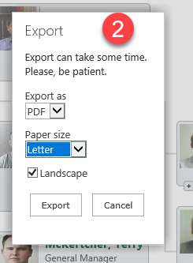
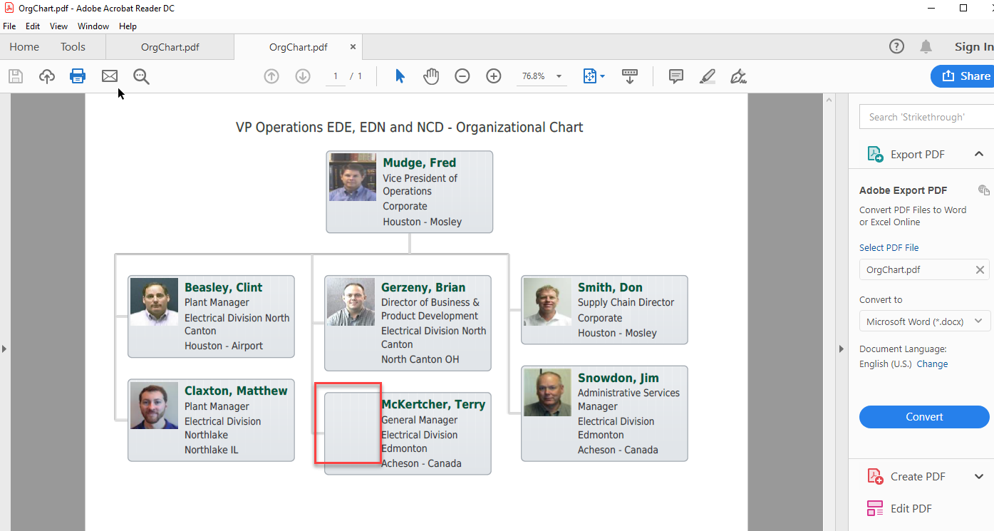
In the above example Terry McKertcher’s image is missing, but in a previous print to PDF version, Matthew Claxton’s image was missing!
Source List entries:
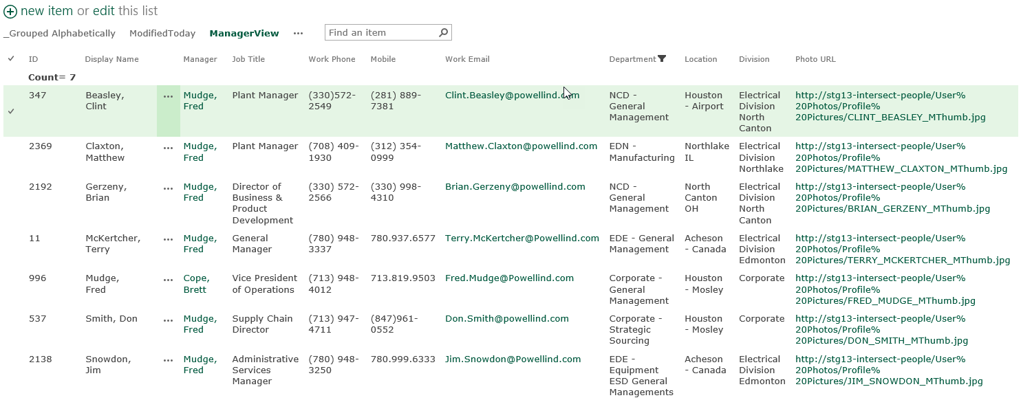

Settings: (Copied from the web part settings page)
Customized Tooltip template
<div class="pl-item-photo">
{{#if PhotoUrl}}
{{#if ListItemURL}}
<a href="{{ListItemURL}}" target="_blank">
{{safeImage PhotoUrl}}
</a>
{{else}}
{{safeImage PhotoUrl}}
{{/if}}
{{/if}}
</div>
<div class="pl-item-fields">
<div class="field-container header-field">
{{Title}}
</div>
<div class="field-container ">
{{JobTitle}}
</div>
<div class="field-container ">
{{Department}}
</div>
<div></br></div>
<div class="field-container ">
Office: {{WorkPhone}}
</div>
<div class="field-container ">
Mobile: {{Mobile}}
</div>
<div></br></div>
<div class="field-container ">
Location: {{Office}}
</div>
<div class="field-container ">
Division: {{Division}}
</div>
<div class="field-container ">
Email: {{WorkEmail}}
</div>
{{#if ListItemURL}}
<div class="personal-page-link">
<a href="{{ListItemURL}}"
title="Navigate to personal page"
target="_blank">View profile</a>
</div>
{{/if}}
</div>

Custom JavaScript
renderer.onBoxRendered(function(event, box, itemData){
//Box rendered event
});

renderer.onTooltipRendered(function(event, tooltip, itemData){
//Tooltip rendered event
});

renderer.onSearchResultRendered(function(event, searchResult, itemData){
//Search result rendered event
});

//Custom code to scale box:
renderer.onInitialLoadingFinished(function(){

renderer.showLoadingPanel();

var $pochContent = renderer.querySelector(".poch-content")
var $viewPort = renderer.querySelector(".poch-control").children().first();
var viewPort = $viewPort[0];
var topOffset = 20;
var currentZoom = 1;

function adjustWidth(){

var realViewPortWidth = viewPort.scrollWidth * currentZoom;
var contentWidth = $pochContent.width();

if(realViewPortWidth > contentWidth){

currentZoom = currentZoom - 0.1;
if(currentZoom > 0){
renderer.zoom(currentZoom);
adjustWidth();
}
}
else {
renderer.hideLoadingPanel();
renderer.dataProvider.getRootItemId(function(rootId){
renderer.scrollToBox(rootId);
});
}
}

setTimeout(adjustWidth, 50);

});

var printHeader = "VP Operations EDE, EDN and NCD - Organizational Chart";

renderer.onLoadingFinished(function(){

var $printHeader = renderer.domQueryHelper.querySelector(".poch-print-header");

var printHeaderFound = $printHeader.length !== 0;

if(!printHeaderFound){
var $nodeList = renderer.domQueryHelper.getRootNodeList();
$nodeList.prepend("<div class='poch-print-header'>" + printHeader +"</div>");
}

});

Custom CSS
/*Example: Change background color for all boxes*/
/*
.poch-web-part .pl-item .pl-item-template{
background-color: black;
border-color: black;
}
*/
.pl-item-fields a:hover {
color: #00593E;
}

.pl-item-tooltip .pl-item-fields a, .pl-item-tooltip .pl-item-fields a:hover, .pl-item-tooltip .pl-item-fields a:visited {
color: #00593E;
}
.personal-page-link {
display: none;
}
.pl-item-tooltip .header-field {
color: #00593E;
}
.poch-content {
border: 0px;
background-color: white;
}
.pl-item-tooltip .pl-item-fields {
white-space: nowrap;
}
.poch-print-header {
display: none;
font-family: Arial, Helvetica, sans-serif;
font-size: 16px;
text-align: center;
padding-bottom: 18px;
}

.pl-print-mode .poch-print-header {
display: block;
}

Issue 2: Cannot save PDF to a file from Adobe. Info for Installed Acrobat - Version: 19.12.20040.345533
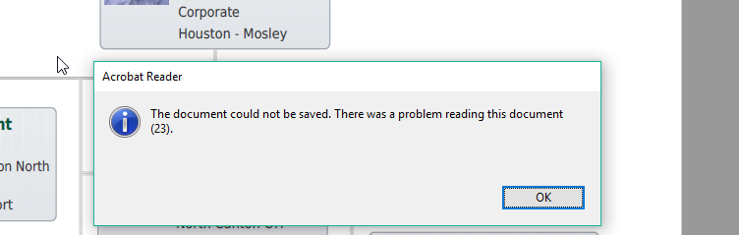
I can print using “Microsoft Print to PDF”, but the results are less than desired with the i’s and l’s are not the same font. (See image below)
The “Save As” is the only option that does not give an error. Open and Save and open have issues.
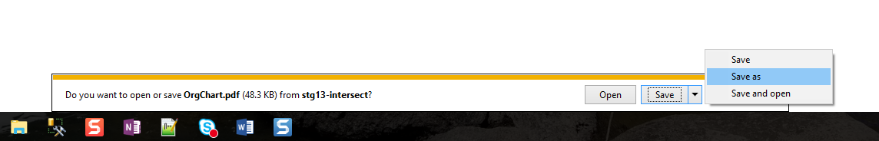

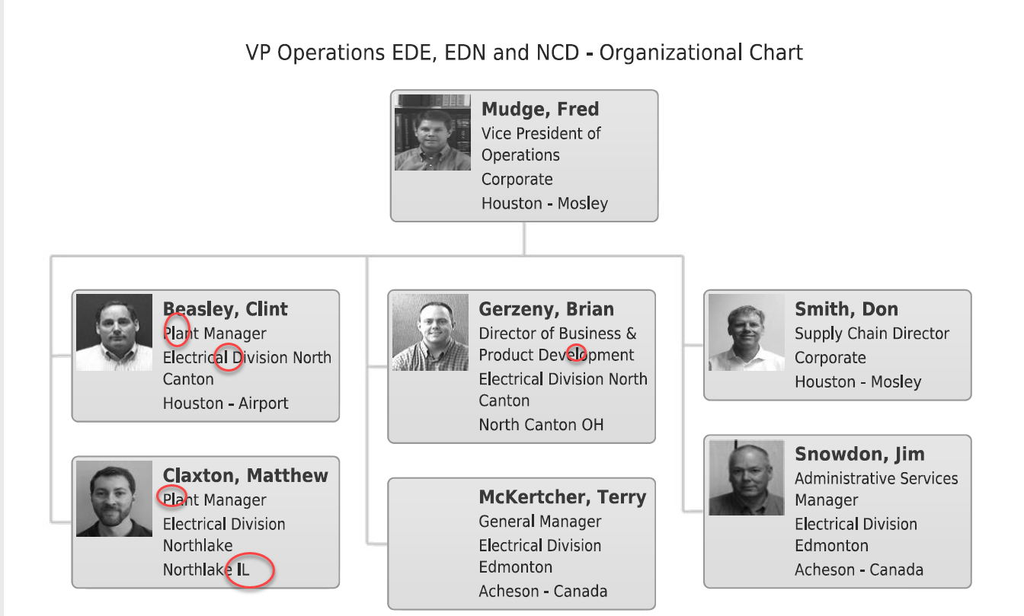
Issue 3: I believe this is happening everywhere on my org site pages.
Attempting to print to PDF after “Clearing Cache” results in all images are missing. To fix, you must leave the page and return.
Web part page:
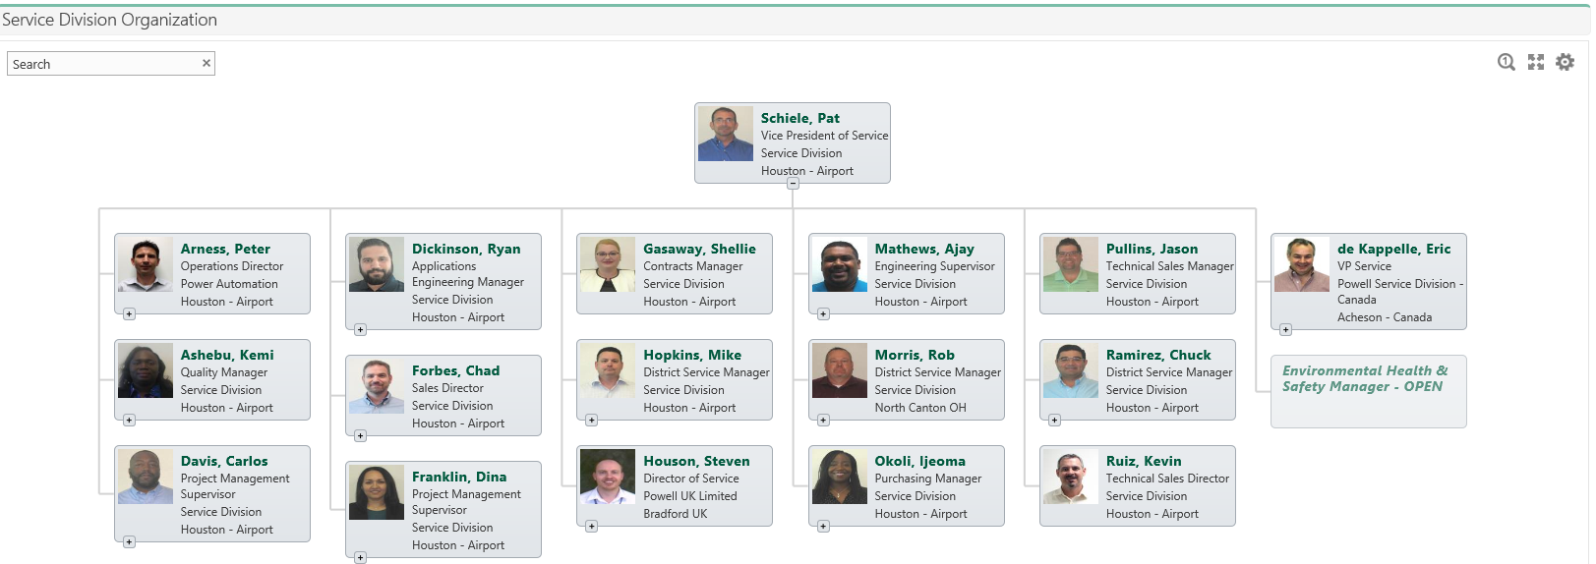

Print before clearing cache
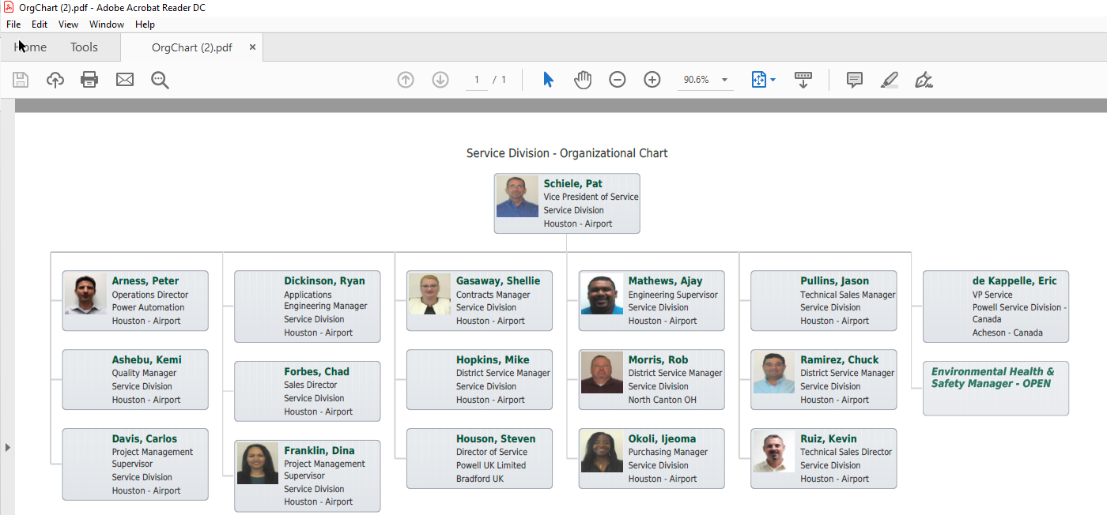

After clearing cache (notice the header is missing too!)

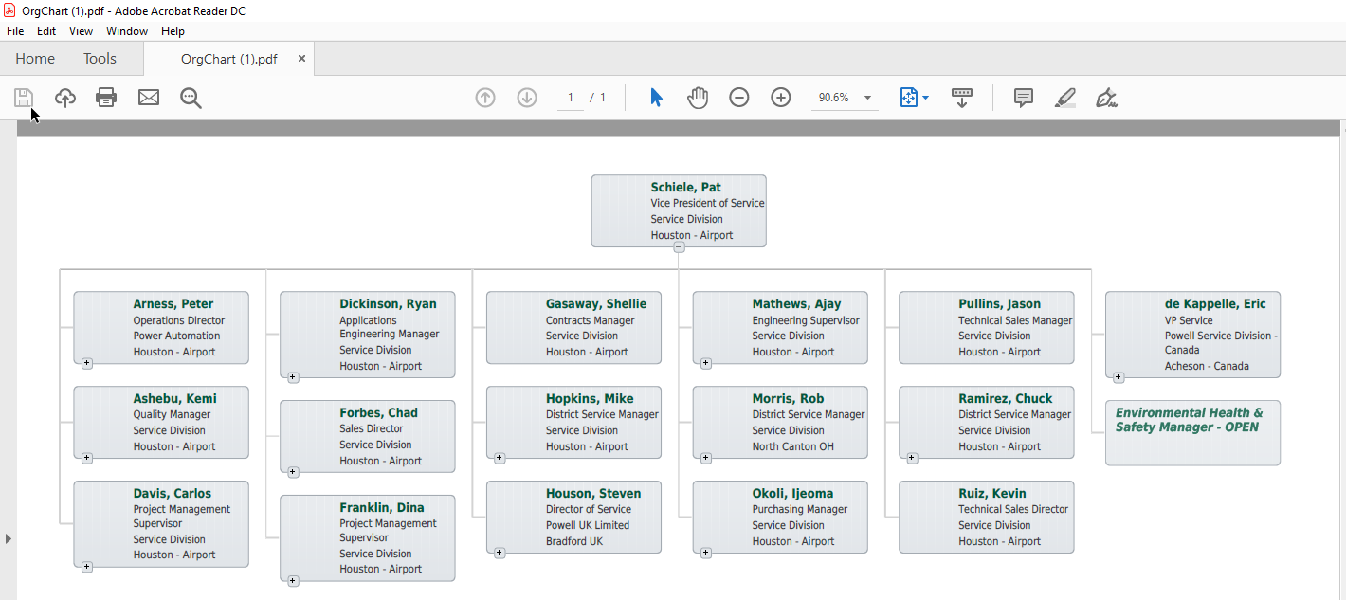
After leaving closing Adobe. Leaving the page and returning to print again:
(Notice Pat Schiele’s image is now missing!)
