Thank you for your response!

I think what I was expecting was to get Carlos and Dina on the same chart.

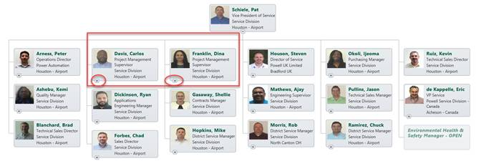

Here are the source records:

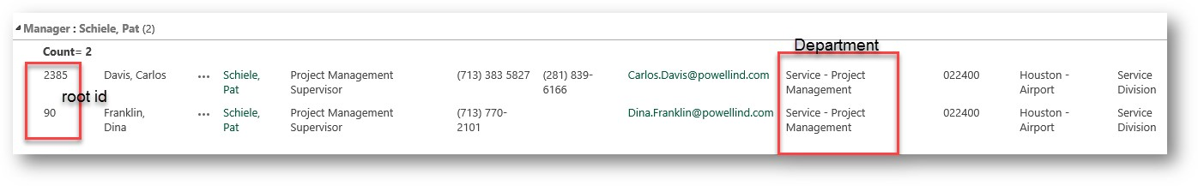



**ToolTipHTML-Mode**  
  
<div class="pl-item-photo">

{{#if PhotoUrl}}

{{#if ListItemURL}}

<a href="{{ListItemURL}}" target="_blank">

{{safeImage PhotoUrl}}

</a>

{{else}}

{{safeImage PhotoUrl}}

{{/if}}

{{/if}}

</div>

<div class="pl-item-fields">

<div class="field-container header-field">

{{Title}}

</div>

<div class="field-container ">

{{JobTitle}}

</div>

<div class="field-container ">

{{Department}}

</div>

<div></br></div>

<div class="field-container ">

Office: {{WorkPhone}}

</div>

<div class="field-container ">

Mobile: {{Mobile}}

</div>

<div></br></div>

<div class="field-container ">

Location: {{Office}}

</div>

<div class="field-container ">

Division: {{Division}}

</div>

<div class="field-container ">

Email: {{WorkEmail}}

</div>

{{#if ListItemURL}}

<div class="personal-page-link">

<a href="{{ListItemURL}}"

title="Navigate to personal page"

target="_blank">View profile</a>

</div>

{{/if}}

</div>

**Custom JavaScript**renderer.onBoxRendered(function(event, box, itemData){

//Box rendered event

});

renderer.onTooltipRendered(function(event, tooltip, itemData){

//Tooltip rendered event

});

renderer.onSearchResultRendered(function(event, searchResult, itemData){

//Search result rendered event

});

//Custom code to scale box:

renderer.onInitialLoadingFinished(function(){

renderer.showLoadingPanel();

var $pochContent = renderer.querySelector(".poch-content")

var $viewPort = renderer.querySelector(".poch-control").children().first();

var viewPort = $viewPort[0];

var topOffset = 20;

var currentZoom = 1;

function adjustWidth(){

var realViewPortWidth = viewPort.scrollWidth * currentZoom;

var contentWidth = $pochContent.width();

if(realViewPortWidth > contentWidth){

currentZoom = currentZoom - 0.1;

if(currentZoom > 0){

renderer.zoom(currentZoom);

adjustWidth();

}

}

else {

renderer.hideLoadingPanel();

renderer.dataProvider.getRootItemId(function(rootId){

renderer.scrollToBox(rootId);

});

}

}

setTimeout(adjustWidth, 50);

});

var printHeader = "Electrical Division Airport - Organizational Chart";

renderer.onLoadingFinished(function(){

var $printHeader = renderer.domQueryHelper.querySelector(".poch-print-header");

var printHeaderFound = $printHeader.length !== 0;

if(!printHeaderFound){

var $nodeList = renderer.domQueryHelper.getRootNodeList();

$nodeList.prepend("<div class='poch-print-header'>" + printHeader +"</div>");

}

});

**CustomCSS**

/*Example: Change background color for all boxes*/

/*

.poch-web-part .pl-item .pl-item-template{

background-color: black;

border-color: black;

}

*/

.pl-item-fields a:hover {

color: #00593E;

}

.pl-item-tooltip .pl-item-fields a, .pl-item-tooltip .pl-item-fields a:hover, .pl-item-tooltip .pl-item-fields a:visited {

color: #00593E;

}

.personal-page-link {

display: none;

}

.pl-item-tooltip .header-field {

color: #00593E;

}

.poch-content {

border: 0px;

background-color: white;

}

.pl-item-tooltip .pl-item-fields {

white-space: nowrap;

}

.poch-print-header {

display: none;

font-family: Arial, Helvetica, sans-serif;

font-size: 16px;

text-align: center;

padding-bottom: 18px;

}

.pl-print-mode .poch-print-header {

display: block;

}

I’m trying to avoid having multiple department pages. This happens at other divisions as well. Drives me crazy….

: )

Thanks so much for your help.  
Theresa